Internet Explorer

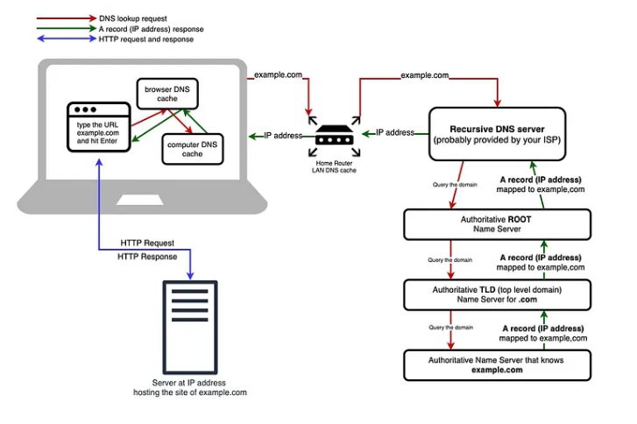
- The user enters a website URL in the browser (client).
- The browser first checks its DNS cache to find the IP address.
- If not found, the request goes to the local router and then to the recursive DNS server.
- The DNS server contacts the Root server, TLD server, and Authoritative server to get the correct IP address.
- The IP address is returned back to the browser.
- The browser sends an HTTP request to the web server using this IP address.
- The server responds with the website data (HTML, CSS, images).
- The browser displays the webpage to the user.

